**Ideation Workshop: Brainstorming**

**Aim**: familiarise with an approach to ideation that generates more ideas than any single individual could – brainstorming.

Although brainstorming is used here as an ideation technique, it may of course be used whenever a creative solution is needed e.g. when planning how to bring the developed artefact to market, or how to study users.

# 2. Brainstorming

Write some questions to direct your session. The exact questions will be unique to your user information, and kind of rendezvous – here are some examples.

a) Prepare 1 or two energising **“How might we …” questions**:

“How might we … <MEET THE NEED STATED IN THE USER EPIC STATEMENT>

For example, how about ‘How Might We …’:

‘reduce repetition and duplication of communications for organisers’?

‘provide busy parents with more opportunities to squeeze in additional tasks en route to a destination’

2a) Generate ROUND 1: Create as Many ways of meeting the need as possible

a) Write a ‘How Might we …’ question on the board.

b) Set a limited time.

c) Adopt an active, high-energy attitude.

d)Generate ideas.

Ideation should follow these rules:

* One conversation at a time
* Go for quantity
* Headline! (concise, highlight important information, high impact)
* Build on the Ideas of Others (recall, collaboration should beat individual genius everytime)
* Encourage wild ideas
* Be visual
* Stay on Topic
* Defer Judgement – NO blocking (assessment – that comes later)

Enforce these rules by reminding the group of the value of following them – the will increase the creative output of the group.

**TIP: Prepare the Space**

All members should:

Have continuous and easy access to the shared contributions area, and each other e.g. within two-steps of a flip chart, hold a big felt tip, or sticky notes, and sit around the same large table. No Blocking or Barriers that obstruct a stream of ideas from everyone.

2b) Capture the ideas

Either:

A scribe captures every contribution clearly and faithfully (no omissions)

Or

All-in. Every individual writes down their own ideas, and also shares it verbally with the group.

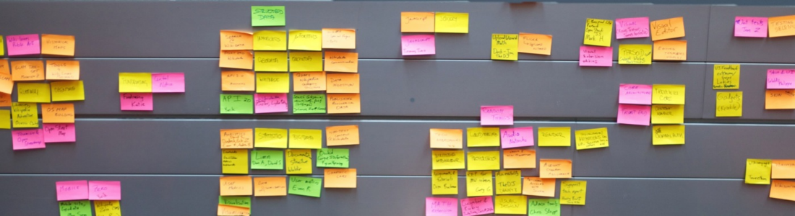

2c) Generate ROUND 2: Create EVEN MORE ways of meeting the need

**a) Ask some provocative questions**

* + 1. **Context Flips**: Now the requirement is for use in:
* a primarily business, rather than social, context, (or vice versa);
* driverless cars
  + 1. **Stretched Metaphors**: **Find of a metaphor** e.g. In some ways, our rendezvous service is like a … “fitness coach, only for rendezvousing. It sets goals, suggests actions, and provides feedback.” **Push the metaphor further** e.g. ‘What if we … also used social forces to change behaviour by posting goals and feedback on face book.’

**b) Ask some re-framing questions** about constraints:

* What if it had to be …<X> ?
* What would a paper-based version look like?
* How would another persona do it?
* **Increase/Reduce**. Change the context by increasing or decreasing a critical parameter by a power of ten e.g. if typically assumption for time allowance would be 2-3hrs, what if average 15mins, or what if there was 1day spread over a week?
* Or **add/remove a parameter** e.g. what if you need not be present at all? What if London had skype in tuk-tuks (2-person scooterised cabs)

# 3) Select best ideas

There are **different selection methods**:

i) each member independently votes for the three most attractive ideas. Every member gets a voice.

ii) elect one or two ideas for each of the following categories:

* Rationale Choice;
* Likely to Delight;
* “Darling” (most popular, likable, sweet);
* Long Shot.

With this method, crazy but meaningful solutions are more likely to survive.

iii) elect one or two ideas in each category, according to the likely form factor:

* physical prototype
* digital prototype
* experience prototype (role play)

Then take a photo of your flip chart, add them to a .ppt, name it ‘Group_Name: Brainstorm1’